|  |  |  |  |  |  |  |
| --- | --- | --- | --- | --- | --- | --- |
| |  |  |  |  | | --- | --- | --- | --- | | **logo ngan.png** | | **MINISTRY OF EDUCATION AND TRAINING** | | | **FPT UNIVERSITY** | | |
| Capstone Project Document |
| Maid Services |
| |  |  |  |  |  |  |  |  |  |  |  | | --- | --- | --- | --- | --- | --- | --- | --- | --- | --- | --- | | |  |  | | --- | --- | | **Group 06 – Report 1** | | | **Group member** | Bùi Tiến Tuân - Team Leader - SE60824  Mạnh Quang Tuyến - Team Member - SE60890  Trương Hải Đăng - Team Member - SE60841  Nguyễn Tấn Công - Team Member - SE60920 | | **Supervisor** | Mr. Nguyễn Trọng Tài | | **Ext. Supervisor** | N/A | | **Capstone Project code** | MS | | |

-Ho Chi Minh City, 09/2014-

# Table of Contents

Table of Contents 2

2.1 User Requirement Specification 3

2.1.1 Guest requirement 3

2.1.2 Staff requirement 3

2.1.3 Customer requirement 3

2.1.4 Maid mediator requirement 3

2.1.5 Maid requirement 4

2.1.6 Webmaster requirement 4

2.1.7 System requirement 4

2.2 System Requirement Specification 4

2.2.1 External Interface Requirements 4

2.2.1.1 User Interfaces 4

2.2.1.2 Hardware Interfaces 4

2.2.1.3 Software Interfaces 4

2.2.1.4 Communications Protocol 4

2.2.2 System Features 4

2.2.2.1 List of use case 4

2.2.2.2 Use Case model: 6

2.2.2.3 Use-case diagram 7

2.2.3 Software System Attributes 73

2.2.3.1 Reliability 73

2.2.3.2 Availability 73

2.2.3.3 Security 74

2.2.3.4 Maintainability 74

2.2.3.5 Portability 74

2.2.3.6 Performance 74

2.3 Entity Relationship Diagram or Data Structures 75

2.4 Other material (if any) 75



## User Requirement Specification

|  |  |
| --- | --- |
| Actor | Description |
| **Guest** | A person not login. They have some simple function search. |
| **Staff** | A person help staff and customer connect together and post job request for Maid |
| **Customer** | Hiring maids. They can search, comment rating for job request posted by Maid or Maid Mediator. |
| **Maid Mediator** | They help maid post job request. |
| **Maid** | They can post job request. |
| **Webmaster** | They manager website. |
| **System** | Implement suggestions. |

### Guest requirement

To satisfy the demand of guest, system has these functions:

* **Register account:** guest need to register to become member.
* **Login**: when guest have account they can login with username and password.
* **Search jobs:** guest can search information about jobs, before they determine become a member.

### Staff requirement

A person: to manage the maid’s request, fee and allow maid to post request.

* **Manage post time**: staff manage maid’s request post time.
* **View post time**: staff can allow customer and maid the time that maid’s request posted.
* **Manage fee**: staff can manage the customer’s fee, maid’s fee
* **Confirm request**: staff can allow the maid’s request to post to the website.

### Customer requirement

A person:

* **Search maids**:
* **Rating**:
* **Comment**:
* **Manage recruitment**:
* **View customer statistic**:

### Maid mediator requirement

A person:

* **Apply job**:
* **Search jobs**:
* **Manage job request**:
* **View maid statistic**:

### Maid requirement

A person:

* **M**:

### Webmaster requirement

A person:

* **Manager user**:

### System requirement

A person:

* **Suggests**:
* **Handle unconfirmed request**:
* **Notify**:

## System Requirement Specification

### External Interface Requirements

#### User Interfaces

* The general interface of website is simple and simplifies user interfaces.
* The design is simple and monochrome is more prefer.
* The layout of information in page is showing simple but full of functions.
* The error, warning and notification messages must be simple, neat, and easy to understand. Error warning does not discomfort to the user.
* The working layout of user is spacious.
* Member can contact with manager and admin easily.

#### Hardware Interfaces

There is no extra hardware interfaces are needed. The system will use the standard hardware and data communications resources of a standard computer.

#### Software Interfaces

Browsers: Firefox, Chrome

#### Communications Protocol

BSF website uses HTTP/HTTPS protocol for communication with the web browser and the web server. In addition, TCP/IP network protocol for communication with HTTP protocol

### System Features

#### List of use case

|  |  |  |  |  |  |  |  |  |
| --- | --- | --- | --- | --- | --- | --- | --- | --- |
| No. | Use case name | Use case ID | Guest | Staff | Customer | Maid mediator | Webmaster | System |
| 1 | Register | 001 | x |  |  |  |  |  |
| 2 | Login | 002 | x |  |  |  |  |  |
| 3 | Search | 003 | x | x | x | x |  |  |
| 4 | Advance Search | 004 | x | x | x | x |  |  |
| 5 | Search by Age | 005 | x | x | x | x | x |  |
| 6 | Search by Skill | 006 | x | x | x | x | x |  |
| 7 | Search by Gender | 007 | x | x | x | x | x |  |
| 8 | Search by Salary | 008 | x | x | x | x | x |  |
| 9 | Search by Time | 009 | x | x | x | x | x |  |
| 10 | Notify | 010 |  |  |  |  |  | x |
| 11 | Manage User | 011 |  |  |  |  | x |  |
| 12 | View Webmaster Statistic | 012 |  |  |  |  | x |  |
| 13 | Add Staff | 013 |  |  |  |  | x |  |
| 14 | Suggest | 014 |  |  |  |  |  | x |
| 15 | Manage JobRequest and Recruitment | 015 |  | x |  |  |  |  |
| 16 | View Staff Statistic | 016 |  | x |  |  |  |  |
| 17 | Manage JobRequest | 017 |  | x |  | x |  |  |
| 18 | Manage Maid | 018 |  | x |  | x |  |  |
| 19 | View Maid Mediator Statistic | 019 |  |  |  | x |  |  |
| 20 | Log out | 020 |  | x | x | x | x |  |
| 21 | Edit Profile | 021 |  | x | x | x |  |  |
| 22 | Payment | 022 |  |  | x |  |  |  |
| 23 | Manage Recruitment | 023 |  |  | x |  |  |  |
| 24 | View Maid statistic | 024 |  |  |  | x |  |  |
| 25 | Rate JobRequest | 025 |  |  | x |  |  |  |
| 26 | Apply JobRequest | 026 |  |  | x |  |  |  |
| 27 | View Customer Statistic | 027 |  |  | x |  |  |  |
| 28 | Suggest JobRequest | 028 |  |  |  |  |  | x |
| 29 | Send SMS | 029 |  |  |  |  |  | x |
| 30 | Send Email | 030 |  |  |  |  |  | x |
| 31 | Show Notification on Website | 031 |  |  |  |  |  | x |
| 32 | Post Recruitment | 032 |  |  | x |  |  |  |
| 33 | Edit Recruitment | 033 |  |  | x |  |  |  |
| 34 | View Personal Statistic | 034 |  | x | x | x |  |  |
| 35 | Add Maid | 035 |  | x |  | x |  |  |
| 36 | Edit Maid | 036 |  | x |  | x |  |  |
| 37 | Post JobRequest | 037 |  | x |  | x |  |  |
| 38 | Edit JobRequest | 038 |  | x |  | x |  |  |
| 39 | Acitve JobRequest | 039 |  | x |  |  |  |  |
| 40 | Active Recruitment | 040 |  | x |  |  |  |  |
| 41 | Approved JobRequest | 041 |  | x |  |  |  |  |
| 42 | View Request Statistic | 042 |  | x |  |  | x |  |
| 43 | View Income Statistic | 043 |  | x |  |  | x |  |
| 44 | Manage Config | 044 |  |  |  |  | x |  |
| 45 | Manage Price | 045 |  |  |  |  | x |  |
| 46 | Manage Number of Kmean | 046 |  |  |  |  | x |  |
| 47 | Manage Number of Weeks | 047 |  |  |  |  | x |  |
| 48 |  | 04 |  |  |  |  |  |  |

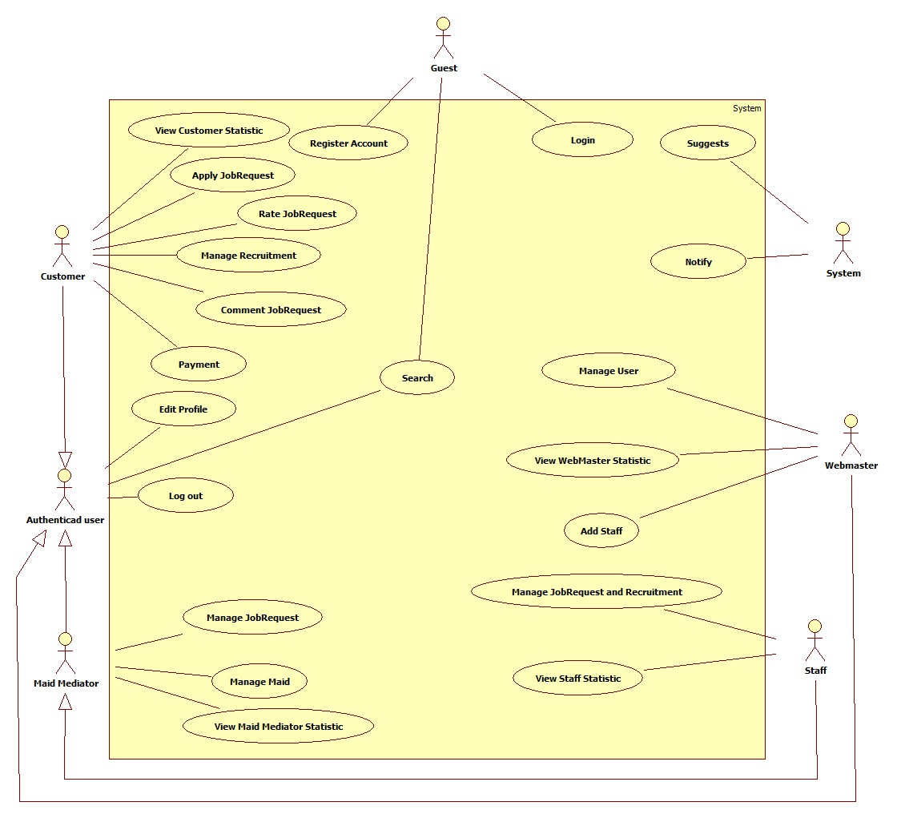

#### Use Case model:

#### Use-case diagram

##### <System> Suggest JobRequest

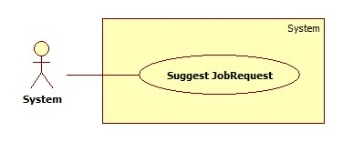

|  |  |  |  |  |
| --- | --- | --- | --- | --- |
| **USE CASE SPECIFICATION** | | | | |
| **Use-case No.** | UC019 | **Use-case Version** | | 1.0 |
| **Use-case Name** | Suggest JobRequest | | | |
| **Author** | TuanBT | | | |
| **Date** | 24/09/2014 | **Priority** | High | |
| **Actor:** System  **Summary:** system automatically suggest JobRequest for customer when they post a recruitment on MS-Website.  **Goal:**  The use case will help MS-Website suggest JobRequest for customer when they post a recruitment.  **Trigger:**   * Click [Đăng yêu cầu tuyển việc] button. * Fill all data. * Click [Đăng yêu cầu] button.   **Pre-conditions:**   * Post an invalid recruitment.   **Post conditions:**   * Success: Suggested JobRequests list will appear. * Failure: Nothing is displayed at suggesting field.   **Main Success Scenario:**   |  |  | | --- | --- | | Actor Action | System Response | | 1. User click on the [Đăng yêu cầu tuyển việc] button.   [Alternative 1] | 1. Show suggested JobRequests list.   [Exception 1] |   **Alternative Scenario:**   |  |  | | --- | --- | | Actor Action | System Response | | 1. User click on the [Đăng yêu cầu] button. | 1. Show suggested JobRequests list. |   **Exceptions:**   |  |  | | --- | --- | | Actor Ation | System Response | | 1. System fail to load data | 1. Show suggested JobRequests list |   **Relationships:** N/A  **Business Rules:**  When customer posts a Recruitment, the system will use Kmean Algorithms to put this Recruitment in a group. The system will show up to 10 JobRequests with status “Waiting” and isActive is True in the same group. The JobRequests list will be arranged in order of descending by distance from the center point of that group. | | | | |

##### <System> Send SMS

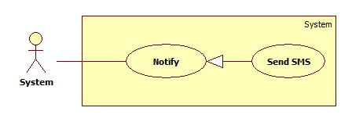

|  |  |  |  |  |
| --- | --- | --- | --- | --- |
| **USE CASE SPECIFICATION** | | | | |
| **Use-case No.** | UC020 | **Use-case Version** | | 1.0 |
| **Use-case Name** | Send SMS | | | |
| **Author** | TuanBT | | | |
| **Date** | 24/09/2014 | **Priority** | Normal | |
| **Actor:** System  **Summary:** Notify for Maid, Customer, Maid Mediator or Staff when Customer apply JobRequest of Maid.  **Goal:**  Send SMS for Maid, Customer, Maid Mediator or Staff when Customer apply JobRequest of Maid. System know when accept a job.  **Trigger:** Both Customer and Maid post an invalid recruitment and job request. Customer must apply successful JobRequest.  **Pre-conditions:**   * Apply success.   **Post conditions:**   * Success: Send SMS * Failure: Don’t send SMS   **Main Success Scenario:**   |  |  | | --- | --- | | Actor Action | System Response | | 1. Customer apply JobRequest of Maid | 1. Send SMS   [Exception 1] |   **Alternative Scenario:**   |  |  | | --- | --- | | Actor Action | System Response | | N/A | N/A |   **Exceptions:**   |  |  | | --- | --- | | Actor Action | System Response | | 1. Number is blank | 1. No |   **Relationships:** Send SMS is generalization of Notification  **Business Rules:** System will send SMS, help maid, customer, Maid mediator or staff know when request of them apply. | | | | |

##### <System> Send Notifications

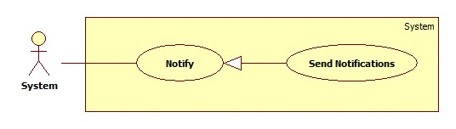

|  |  |  |  |  |
| --- | --- | --- | --- | --- |
| **USE CASE SPECIFICATION** | | | | |
| **Use-case No.** | UC020 | **Use-case Version** | | 1.0 |
| **Use-case Name** | Send Notifications | | | |
| **Author** |  | | | |
| **Date** | 24/09/2014 | **Priority** | Normal | |
| **Actor:** System  **Summary:** Notify for Maid, Customer, Maid Mediator or Staff when Customer apply JobRequest of Maid. Notify for all Staff when customer report about payment.  **Goal:**  Help user know what happen with them.  **Trigger:** Both Customer and Maid post an invalid recruitment and job request. Customer must apply successful JobRequest.  **Pre-conditions:**   * User must login into MS-Website.   **Post conditions:**   * Success: Notification show at notify page of User was send Notification. * Failure: Do not show notification.   **Main Success Scenario:**   |  |  | | --- | --- | | Actor Action | System Response | | 1. Customer apply JobRequest of Maid | 1. Send SMS |   **Alternative Scenario:**   |  |  | | --- | --- | | Actor Action | System Response | | N/A | N/A |   **Exceptions:**   |  |  | | --- | --- | | Actor Action | System Response | |  |  |   **Relationships:** Send notificatrion is generalization of Notifier  **Business Rules:** System will send notification, help maid, customer, Maid mediator or staff know when request of them apply. | | | | |

##### <Webmaster> Add Staff

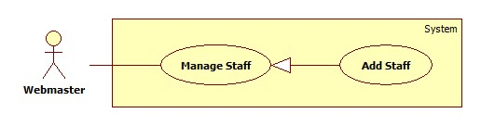

|  |  |  |  |  |
| --- | --- | --- | --- | --- |
| **USE CASE SPECIFICATION** | | | | |
| **Use-case No.** | UC001 | **Use-case Version** | | 1.0 |
| **Use-case Name** | Add staff | | | |
| **Author** | TuanBT | | | |
| **Date** | 24/09/2014 | **Priority** | High | |
| **Actor:** Webmaster  **Summary:** Webmaster add a user role Staff. A new staff only have username and password.  **Goal:** Make a new user directive.  **Trigger:**Webmater click on “Thêm nhân viên”  **Pre-conditions:**   * User must login with Admin role. * Register page will be shown   **Post conditions:**   * Success: Reload this page * Failure: Show message error   **Main Success Scenario:**   |  |  | | --- | --- | | Actor Action | System Response | | 1. Webmaster click “Thêm nhân viên” at his profile page.  3. Webmaster fill and click “Thêm nhân viên” button. | 2. The page show 3 input username, password, re-password.  4. Page is reload.  [Exception 1] [Exception 2] |   **Alternative Scenario:**   |  |  | | --- | --- | | Actor Action | System Response | |  |  |   **Exceptions:**   |  |  | | --- | --- | | Actor Action | System Response | | [Exception 1]  1. Input “Tên đăng ký” is missing  [Exception 1]  1. Input “Mật khẩu” is missing or password not match with input “Nhập lại mật khẩu” | 2. Show error “Vui lòng nhập tên đăng nhập”  2. Show error “Mật khẩu không trùng khớp” |   **Relationships:** Add staff is generalization of manage staff  **Business Rules:** N/A | | | | |

##### <Webmaster> Banned Account

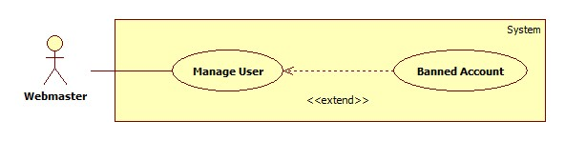

|  |  |  |  |  |
| --- | --- | --- | --- | --- |
| **USE CASE SPECIFICATION** | | | | |
| **Use-case No.** | UC001 | **Use-case Version** | | 1.0 |
| **Use-case Name** | Bannned Account | | | |
| **Author** | TuanBT | | | |
| **Date** | 24/09/2014 | **Priority** | High | |
| **Actor:** Webmaster  **Summary:** Webmaster will banned account.  **Goal:**  Banned Account.  **Trigger:** Webmaster click “Khóa tài khoản”  **Pre-conditions:**   * User must login with Admin role * Banned Account page will be shown   **Post conditions:**   * Success: Reload this page. Button will change to “Kích hoạt” * Failure: Do not reload page   **Main Success Scenario:**   |  |  | | --- | --- | | Actor Action | System Response | | 1. Webmaster click “Khóa tài khoản” menu, then click “Khóa” button. | 2. Reload page and change button to “Kích hoạt” |   **Alternative Scenario:**   |  |  | | --- | --- | | Actor Action | System Response | |  |  |   **Exceptions:**   |  |  | | --- | --- | | Actor Action | System Response | |  |  |   **Relationships:** Banned Account extend of manage user  **Business Rules:** N/A | | | | |

##### <Webmaster> Active Account

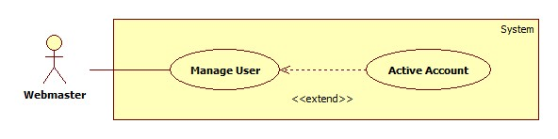

|  |  |  |  |  |
| --- | --- | --- | --- | --- |
| **USE CASE SPECIFICATION** | | | | |
| **Use-case No.** | UC001 | **Use-case Version** | | 1.0 |
| **Use-case Name** | Active Account | | | |
| **Author** | TuanBT | | | |
| **Date** | 24/09/2014 | **Priority** | High | |
| **Actor:** Webmaster  **Summary:** Webmaster will active account.  **Goal:** Active account.  **Trigger:** Webmaster click “Kích hoạt”  **Pre-conditions:**   * User must login with Admin role * Active Account page will be shown   **Post conditions:**   * Success: Reload this page. Button will change to “Khóa” * Failure: Do not reload page   **Main Success Scenario:**   |  |  | | --- | --- | | Actor Action | System Response | | 1. Webmaster click “Khóa tài khoản” menu, then click “Kích hoạt” button. | 2. Reload page and change button to “Khóa” |   **Alternative Scenario:**   |  |  | | --- | --- | | Actor Action | System Response | |  |  |   **Exceptions:**   |  |  | | --- | --- | | Actor Action | System Response | |  |  |   **Relationships:** Active Account extend of Manage acount  **Business Rules:** N/A | | | | |

##### <Webmaster> View Request Statistic

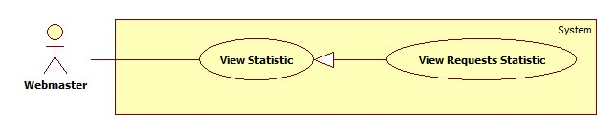

|  |  |  |  |  |
| --- | --- | --- | --- | --- |
| **USE CASE SPECIFICATION** | | | | |
| **Use-case No.** | UC001 | **Use-case Version** | | 1.0 |
| **Use-case Name** | View requests Statistic | | | |
| **Author** | TuanBT | | | |
| **Date** | 24/09/2014 | **Priority** | High | |
| **Actor:** Webmaster  **Summary:** View statistic of all request of MS-Website in year.  **Goal:**  View statistic  **Trigger:** Webmaster click “Thống kê”  **Pre-conditions:**   * User must login with Admin role * Statistic page will be shown   **Post conditions:**   * Success: Show statistic chart * Failure: Do not show chart   **Main Success Scenario:**   |  |  | | --- | --- | | Actor Action | System Response | | 1. Webmaster click “Thống kê” menu then click “Các yêu cầu” link. | 2. Show statistic chart. |   **Alternative Scenario:**   |  |  | | --- | --- | | Actor Action | System Response | |  |  |   **Exceptions:**   |  |  | | --- | --- | | Actor Action | System Response | |  |  |   **Relationships:** View Request Statistic is generalization of View Statistic  **Business Rules:** N/A | | | | |

##### <Webmaster> View Income Statistic

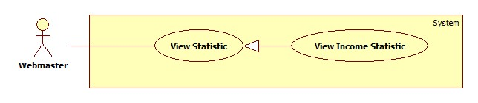

|  |  |  |  |  |
| --- | --- | --- | --- | --- |
| **USE CASE SPECIFICATION** | | | | |
| **Use-case No.** | UC001 | **Use-case Version** | | 1.0 |
| **Use-case Name** | View Income Statistic | | | |
| **Author** | TuanBT | | | |
| **Date** | 24/09/2014 | **Priority** | High | |
| **Actor:** Webmaster  **Summary:** View statistic of all request of MS-Website in year.  **Goal:**  View statistic  **Trigger:** Webmaster click “Thống kê”  **Pre-conditions:**   * User must login with Admin role * Statistic page will be shown   **Post conditions:**   * Success: Show statistic chart * Failure: Do not show chart   **Main Success Scenario:**   |  |  | | --- | --- | | Actor Action | System Response | | 1. Webmaster click “Thống kê” menu then click “Doanh thu” link. | 2. Show statistic chart. |   **Alternative Scenario:**   |  |  | | --- | --- | | Actor Action | System Response | |  |  |   **Exceptions:**   |  |  | | --- | --- | | Actor Action | System Response | |  |  |   **Relationships:** View Income Statistic is generalization of View Statistic  **Business Rules:** N/A | | | | |

##### <Webmaster> Manage JobRequest Price

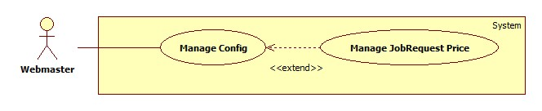

|  |  |  |  |  |
| --- | --- | --- | --- | --- |
| **USE CASE SPECIFICATION** | | | | |
| **Use-case No.** | UC001 | **Use-case Version** | | 1.0 |
| **Use-case Name** | Manage JobRequest Price | | | |
| **Author** | TuanBT | | | |
| **Date** | 24/09/2014 | **Priority** | High | |
| **Actor:** Webmaster  **Summary:** Change price when a new JobRequest post to MS-Website.  **Goal:**  Change value.  **Trigger:** Webmaster click “Quản lý cấu hình”  **Pre-conditions:**   * User must login with Admin role * Manage config page will be shown   **Post conditions:**   * Success: Reload page and change value. * Failure: Show error.   **Main Success Scenario:**   |  |  | | --- | --- | | Actor Action | System Response | | 1. Webmaster click “Quản lý cấu hình” menu, then fill input “Giá mới” | 2. Show notification “Cập nhập đơn giá cho yêu cầu công việc thành công.”  [Exception 1] |   **Alternative Scenario:**   |  |  | | --- | --- | | Actor Action | System Response | |  |  |   **Exceptions:**   |  |  | | --- | --- | | Actor Action | System Response | | [Exception 1]  1. Fill input not a digit. | 2. Show error “Phải nhập số nguyên!” |   **Relationships:** Manage JobRequest Price is extend of Manage config.  **Business Rules:** Webmaster must enter a integer number. | | | | |

##### <Webmaster> Manage Recruitment Price

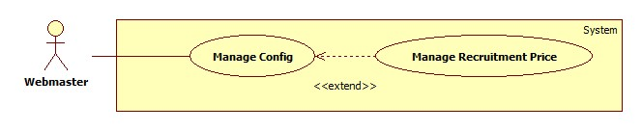

|  |  |  |  |  |
| --- | --- | --- | --- | --- |
| **USE CASE SPECIFICATION** | | | | |
| **Use-case No.** | UC001 | **Use-case Version** | | 1.0 |
| **Use-case Name** | Manage Recruitment Price | | | |
| **Author** | TuanBT | | | |
| **Date** | 24/09/2014 | **Priority** | High | |
| **Actor:** Webmaster  **Summary:** Change price when a new Recruitment post to MS-Website.  **Goal:**  Change value.  **Trigger:** Webmaster click “Quản lý cấu hình”  **Pre-conditions:**   * User must login with Admin role * Manage config page will be shown   **Post conditions:**   * Success: Reload page and change value. * Failure: Show error.   **Main Success Scenario:**   |  |  | | --- | --- | | Actor Action | System Response | | 1. Webmaster click “Quản lý cấu hình” menu, then fill input “Giá mới” | 2. Show notification “Cập nhập đơn giá cho yêu cầu tìm người thành công.”  [Exception 1] |   **Alternative Scenario:**   |  |  | | --- | --- | | Actor Action | System Response | |  |  |   **Exceptions:**   |  |  | | --- | --- | | Actor Action | System Response | | [Exception 1]  1. Fill input not a digit. | 2. Show error “Phải nhập số nguyên!” |   **Relationships:** Manage Recruitment Price is extend of Manage config.  **Business Rules:** Webmaster must enter a integer number. | | | | |

##### <Webmaster> Manage Number of Kmean

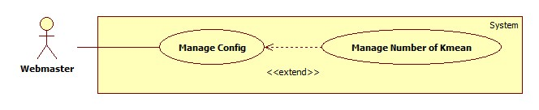

|  |  |  |  |  |
| --- | --- | --- | --- | --- |
| **USE CASE SPECIFICATION** | | | | |
| **Use-case No.** | UC001 | **Use-case Version** | | 1.0 |
| **Use-case Name** | Manage Number of Kmean | | | |
| **Author** | TuanBT | | | |
| **Date** | 24/09/2014 | **Priority** | High | |
| **Actor:** Webmaster  **Summary:** Change number K of Kmean algorithm. K same number of group.  **Goal:**  Change value.  **Trigger:** Webmaster click “Quản lý cấu hình”  **Pre-conditions:**   * User must login with Admin role * Manage config page will be shown   **Post conditions:**   * Success: Reload page and change value. * Failure: Show error.   **Main Success Scenario:**   |  |  | | --- | --- | | Actor Action | System Response | | 1. Webmaster click “Quản lý cấu hình” menu, then fill input “Gợi ý số K” | 2. Show notification “Cập nhập số K thành công.”.  [Exception 1] |   **Alternative Scenario:**   |  |  | | --- | --- | | Actor Action | System Response | |  |  |   **Exceptions:**   |  |  | | --- | --- | | Actor Action | System Response | | [Exception 1]  1. Fill input not a digit. | 2. Show error “Phải nhập số nguyên!” |   **Relationships:** Manage Number of Kmean is extend of Manage config.  **Business Rules:** Number of K must smaller than total of Jobrequest or Recruitment. | | | | |

##### <Webmaster> Manage Number Of Weeks

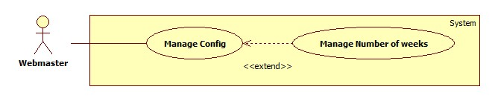

|  |  |  |  |  |
| --- | --- | --- | --- | --- |
| **USE CASE SPECIFICATION** | | | | |
| **Use-case No.** | UC001 | **Use-case Version** | | 1.0 |
| **Use-case Name** | Manage Number of weeks | | | |
| **Author** | TuanBT | | | |
| **Date** | 24/09/2014 | **Priority** | High | |
| **Actor:** Webmaster  **Summary:** Change maximum week when user post a JoRequest or Recruiment in to MS-Website.  **Goal:**  Change value.  **Trigger:** Webmaster click “Quản lý cấu hình”  **Pre-conditions:**   * User must login with Admin role * Manage config page will be shown   **Post conditions:**   * Success: Reload page and change value. * Failure: Show error.   **Main Success Scenario:**   |  |  | | --- | --- | | Actor Action | System Response | | 1. Webmaster click “Quản lý cấu hình” menu, then fill input “Số mới” | 2. Show notification “Cập nhập số tuần thành công.”  [Exception 1] |   **Alternative Scenario:**   |  |  | | --- | --- | | Actor Action | System Response | |  |  |   **Exceptions:**   |  |  | | --- | --- | | Actor Action | System Response | | [Exception 1]  1. Fill input not a digit. | 2. Show error “Phải nhập số nguyên!” |   **Relationships:** Manage Number of weeks is extend of Manage config.  **Business Rules:** Webmaster must enter an integer number. | | | | |
|  | | | | |

##### <Customer> Apply JobRequest

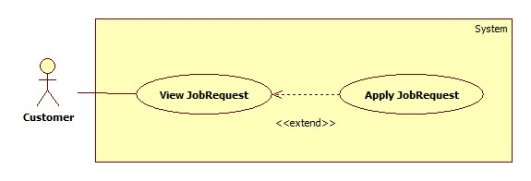

|  |  |  |  |  |
| --- | --- | --- | --- | --- |
| **USE CASE SPECIFICATION** | | | | |
| **Use-case No.** | UC24 | **Use-case Version** | | 1.0 |
| **Use-case Name** | Apply JobRequest | | | |
| **Author** | TuanBT | | | |
| **Date** | 24/09/2014 | **Priority** | High | |
| **Actor:** Customer  **Summary:** Customer use a them Recruitment have status “Waiting” to Apply a JobRequest have status “Waiting” too.  **Goal:**  Apply JobRequest.  **Trigger:** Click button “Thuê"  **Pre-conditions:**   * User must login with Customer role   **Post conditions:**   * Success: Reload page. Name of Customer show at status line. * Failure: Show error “Thuê thất bại”   **Main Success Scenario:**   |  |  | | --- | --- | | Actor Action | System Response | | 1. Customer click a JobRequest have status “Waiting”, then click “Thuê” button.  3. Choose a Recruitment from list Radio button. Then click “Đồng ý” button | 2. Show modal “Xin chọn một đơn tuyển việc”.  4. Show status “Đã được thuê”.  [Exception1] |   **Alternative Scenario:**   |  |  | | --- | --- | | Actor Action | System Response | | [Alternative 1]  1. Customer click a Recruitment in Profile page. Recruitment in tab “Chờ thuê”.  3. Customer click one of them.  5. Click “Thuê” button  7. Click “Chấp nhận” button. | 2. System show some JobRequest in “Những việc có thể hợp” box.  4. System show “Chi tiết yêu cầu công việc” page.  6. System show modal “Xác nhận thuê”.  8. Show status “Đã được thuê”.  [Exception1] |   **Exceptions:**   |  |  | | --- | --- | | Actor Action | System Response | | [Exception 1]  1. Customer click “Chấp nhận” from modal. | 2. Show error “Công việc đã được thuê bởi khách hàng khác” |   **Relationships:** Apply JobRequest is extend of View JobRequest  **Business Rules:**  JobRequest must have status “Waiting”. Have two cases when applying JobRequest: Choose a JobRequest from suggestion of system in Recruitment detail, choose JobRequest from Index or Search. In first case, system automatic choose current Recruitment to apply suggested JobRequest. The second case, customer have to choose one of Recruitments List, if they don’t have any Recruitment, they must post a recruitment.  Sometime this JobRequest is applied by another customer or expired by that time. Customer can not apply JobRequest and receive an error. | | | | |

##### <Customer> Comment JobRequest

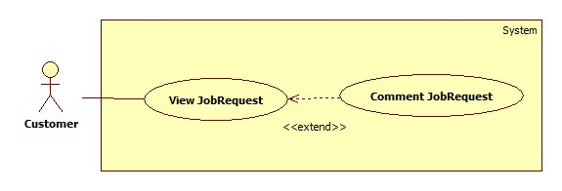

|  |  |  |  |  |
| --- | --- | --- | --- | --- |
| **USE CASE SPECIFICATION** | | | | |
| **Use-case No.** | UC25 | **Use-case Version** | | 1.0 |
| **Use-case Name** | Comment JobRequest | | | |
| **Author** | TuanBT | | | |
| **Date** | 24/09/2014 | **Priority** | High | |
| **Actor:** Customer  **Summary:** When customer applied a JobRequest, they can comment for this JobRequest if Maid come back and tell to staff Approved this Job.  **Goal:**  Comment JobRequest.  **Trigger:** Fill input comment.  **Pre-conditions:**   * User must login with Admin role * Status of JobRequest is Approved   **Post conditions:**   * Success: one line comment show. * Failure: No comment.   **Main Success Scenario:**   |  |  | | --- | --- | | Actor Action | System Response | | 1. Click a jobRequest in “Đã nhận” tab. This JobRequest must have status “Đã hoàn tất”  3. Fill comment input, then click “Đăng” button. | 2. Show box “Nhận xét của người đã thuê”.  4. One line comment is show. |   **Alternative Scenario:**   |  |  | | --- | --- | | Actor Action | System Response | |  |  |   **Exceptions:**   |  |  | | --- | --- | | Actor Action | System Response | |  |  |   **Relationships:** Comment JobRequest is extend of View JobRequest  **Business Rules:** JobRequest must have Approved status which means “Đã hoàn tất”, customer can only comment on this JobReuest. | | | | |

##### <Customer> Rate JobRequest

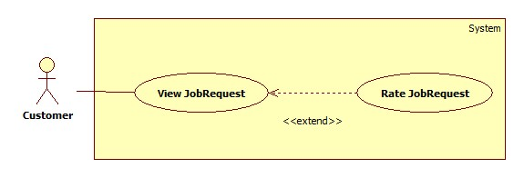

|  |  |  |  |  |
| --- | --- | --- | --- | --- |
| **USE CASE SPECIFICATION** | | | | |
| **Use-case No.** | UC26 | **Use-case Version** | | 1.0 |
| **Use-case Name** | Rate JobRequest | | | |
| **Author** | TuanBT | | | |
| **Date** | 24/09/2014 | **Priority** | High | |
| **Actor:** Customer  **Summary:** When customer applied a JobRequest, they can rate for this JobRequest if Maid come back and tell to staff Approved this Job.  **Goal:**  Rate JobRequest.  **Trigger:** Click choose star. Then click “Chấm điểm” button.  **Pre-conditions:**   * User must login with Admin role * Status of JobRequest is Approved   **Post conditions:**   * Success: Star show in rating line. * Failure: No rate.   **Main Success Scenario:**   |  |  | | --- | --- | | Actor Action | System Response | | 1. Click a jobRequest in “Đã nhận” tab. This JobRequest must have status “Đã hoàn tất”  3. Choose number star, then click “Chấm điểm” button. | 2. Show box “Nhận xét của người đã thuê”.  4. Rate of JobRequest be shown. |   **Alternative Scenario:**   |  |  | | --- | --- | | Actor Action | System Response | |  |  |   **Exceptions:**   |  |  | | --- | --- | | Actor Action | System Response | |  |  |   **Relationships:** Rate JobRequest is extend of View JobRequest  **Business Rules:** JobRequest must have Approved status which mean “Đã hoàn tất”, customer can only Rate on this JobReuest. | | | | |

##### <Customer> Edit Customer Profile

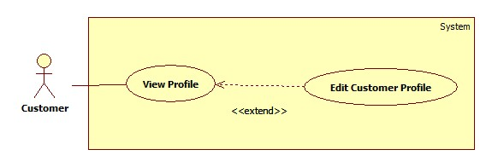

|  |  |  |  |  |
| --- | --- | --- | --- | --- |
| **USE CASE SPECIFICATION** | | | | |
| **Use-case No.** | UC… | **Use-case Version** | | 1.0 |
| **Use-case Name** | Edit Customer Profile | | | |
| **Author** | TuanBT | | | |
| **Date** | 24/09/2014 | **Priority** | High | |
| **Actor:** Customer  **Summary:** …  **Goal:**  …  **Trigger:** …  **Pre-conditions:**   * User must login with Admin role * … page will be shown   **Post conditions:**   * Success: ... * Failure: ….   **Main Success Scenario:**   |  |  | | --- | --- | | Actor Action | System Response | | 1. | 2. |   **Alternative Scenario:**   |  |  | | --- | --- | | Actor Action | System Response | |  |  |   **Exceptions:**   |  |  | | --- | --- | | Actor Action | System Response | | [Exception 1]  1. | 2. |   **Relationships:** N/A  **Business Rules:** N/A | | | | |

##### <Customer> Extend Recruitment

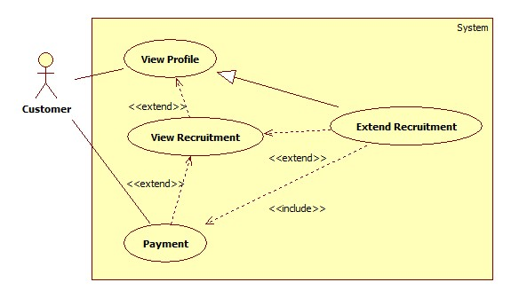

|  |  |  |  |  |
| --- | --- | --- | --- | --- |
| **USE CASE SPECIFICATION** | | | | |
| **Use-case No.** | UC… | **Use-case Version** | | 1.0 |
| **Use-case Name** | Extend Recruitment | | | |
| **Author** | TuanBT | | | |
| **Date** | 24/09/2014 | **Priority** | High | |
| **Actor:** Customer  **Summary:** …  **Goal:**  …  **Trigger:** …  **Pre-conditions:**   * User must login with Admin role * … page will be shown   **Post conditions:**   * Success: ... * Failure: ….   **Main Success Scenario:**   |  |  | | --- | --- | | Actor Action | System Response | | 1. | 2. |   **Alternative Scenario:**   |  |  | | --- | --- | | Actor Action | System Response | |  |  |   **Exceptions:**   |  |  | | --- | --- | | Actor Action | System Response | | [Exception 1]  1. | 2. |   **Relationships:** N/A  **Business Rules:** N/A | | | | |

##### <Customer> Hide Recruitment

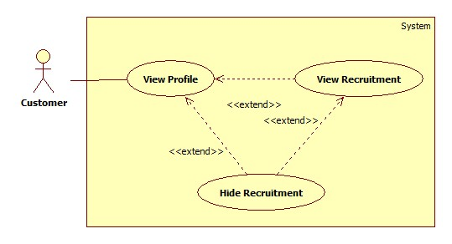

|  |  |  |  |  |
| --- | --- | --- | --- | --- |
| **USE CASE SPECIFICATION** | | | | |
| **Use-case No.** | UC… | **Use-case Version** | | 1.0 |
| **Use-case Name** | Hide Recruitment | | | |
| **Author** | TuanBT | | | |
| **Date** | 24/09/2014 | **Priority** | High | |
| **Actor:** Customer  **Summary:** …  **Goal:**  …  **Trigger:** …  **Pre-conditions:**   * User must login with Admin role * … page will be shown   **Post conditions:**   * Success: ... * Failure: ….   **Main Success Scenario:**   |  |  | | --- | --- | | Actor Action | System Response | | 1. | 2. |   **Alternative Scenario:**   |  |  | | --- | --- | | Actor Action | System Response | |  |  |   **Exceptions:**   |  |  | | --- | --- | | Actor Action | System Response | | [Exception 1]  1. | 2. |   **Relationships:** N/A  **Business Rules:** N/A | | | | |

##### <Customer> Public Recruitment

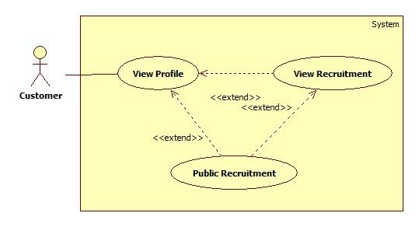

|  |  |  |  |  |
| --- | --- | --- | --- | --- |
| **USE CASE SPECIFICATION** | | | | |
| **Use-case No.** | UC… | **Use-case Version** | | 1.0 |
| **Use-case Name** | Public Recruitment | | | |
| **Author** | TuanBT | | | |
| **Date** | 24/09/2014 | **Priority** | High | |
| **Actor:** Customer  **Summary:** …  **Goal:**  …  **Trigger:** …  **Pre-conditions:**   * User must login with Admin role * … page will be shown   **Post conditions:**   * Success: ... * Failure: ….   **Main Success Scenario:**   |  |  | | --- | --- | | Actor Action | System Response | | 1. | 2. |   **Alternative Scenario:**   |  |  | | --- | --- | | Actor Action | System Response | |  |  |   **Exceptions:**   |  |  | | --- | --- | | Actor Action | System Response | | [Exception 1]  1. | 2. |   **Relationships:** N/A  **Business Rules:** N/A | | | | |

##### <Customer> Post Recruitment

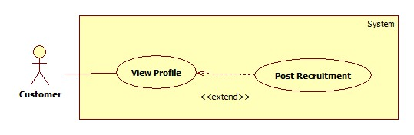

|  |  |  |  |  |
| --- | --- | --- | --- | --- |
| **USE CASE SPECIFICATION** | | | | |
| **Use-case No.** | UC… | **Use-case Version** | | 1.0 |
| **Use-case Name** | Post Recruitment | | | |
| **Author** | TuanBT | | | |
| **Date** | 24/09/2014 | **Priority** | High | |
| **Actor:** Customer  **Summary:** …  **Goal:**  …  **Trigger:** …  **Pre-conditions:**   * User must login with Admin role * … page will be shown   **Post conditions:**   * Success: ... * Failure: ….   **Main Success Scenario:**   |  |  | | --- | --- | | Actor Action | System Response | | 1. | 2. |   **Alternative Scenario:**   |  |  | | --- | --- | | Actor Action | System Response | |  |  |   **Exceptions:**   |  |  | | --- | --- | | Actor Action | System Response | | [Exception 1]  1. | 2. |   **Relationships:** N/A  **Business Rules:** N/A | | | | |

##### <Customer> Edit Recruitment

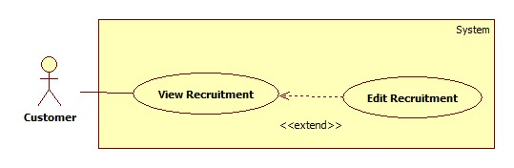

|  |  |  |  |  |
| --- | --- | --- | --- | --- |
| **USE CASE SPECIFICATION** | | | | |
| **Use-case No.** | UC… | **Use-case Version** | | 1.0 |
| **Use-case Name** | Edit Recruitment | | | |
| **Author** | TuanBT | | | |
| **Date** | 24/09/2014 | **Priority** | High | |
| **Actor:** Customer  **Summary:** …  **Goal:**  …  **Trigger:** …  **Pre-conditions:**   * User must login with Admin role * … page will be shown   **Post conditions:**   * Success: ... * Failure: ….   **Main Success Scenario:**   |  |  | | --- | --- | | Actor Action | System Response | | 1. | 2. |   **Alternative Scenario:**   |  |  | | --- | --- | | Actor Action | System Response | |  |  |   **Exceptions:**   |  |  | | --- | --- | | Actor Action | System Response | | [Exception 1]  1. | 2. |   **Relationships:** N/A  **Business Rules:** N/A | | | | |

##### <Customer> Pay

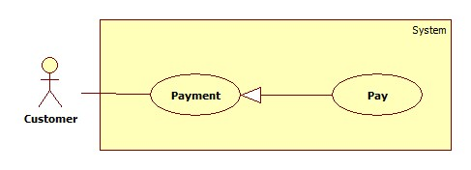

|  |  |  |  |  |
| --- | --- | --- | --- | --- |
| **USE CASE SPECIFICATION** | | | | |
| **Use-case No.** | UC33 | **Use-case Version** | | 1.0 |
| **Use-case Name** | Pay | | | |
| **Author** | TuanBT | | | |
| **Date** | 24/09/2014 | **Priority** | High | |
| **Actor:** Customer  **Summary:** Customer will pay online by Paypal for them Recruitment.  **Goal:**  Pay online by Paypal.  **Trigger:** Post success a Recruitment.  **Pre-conditions:**   * User must login with Admin role * Paypal button will be shown   **Post conditions:**   * Success: Status of Recruitment change to Watting mean “Đang chờ người làm”. * Failure: Button Paypal not hide.   **Main Success Scenario:**   |  |  | | --- | --- | | Actor Action | System Response | | 1. Click Paypal button.  3. Do pay money. | 2. System redirect to Paypal Page.  4. Button Paypal hide, status of Recruitment change to “Đang chờ người làm”.  [Exception 1] |   **Alternative Scenario:**   |  |  | | --- | --- | | Actor Action | System Response | | [Alternative 1]  1. Customer click a Recruitment form “Hết hạn” tab in Profile page. Then Click “Gia hạn” button.  3. Click Paypal button.  5. Do pay money.  [Alternative 2]  1. Customer click title a Recruitment from “Hết hạn” tab in Profile page.  3. Click “Gia hạn” button.  5. Do pay money. | 2. System show “Gia hạn đơn tuyển việc” modal.  4. System redirect to Paypal page.  6. Button Paypal hide, status of Recruitment change to “Đang chờ người làm”.  [Exception 1]  2. System redirect to “Tin tìm người giúp việc” page.  4. System redirect to Paypal page.  6. Button Paypal hide, status of Recruitment change to “Đang chờ người làm”.  [Exception 1] |   **Exceptions:**   |  |  | | --- | --- | | Actor Action | System Response | | [Exception 1]  1. Paypal page not return MS-Website. | 2. Paypal button not Hide. |   **Relationships:** Pay is generalization Payment  **Business Rules:** Recruitment must have paypal account to pay. If the payment process is not successful because whatever resons is, Customer can click “Ấn vào đây” in “Nếu bạn đã thanh toán?” Box in “Tin tìm người giúp việc” page, to contact Staff. After that, Staff must go to website to check if that Recruitment is paid or not. If it is paid, Staff goes to management page to active this Recruitment. | | | | |

##### <Customer> View Customer Statistic

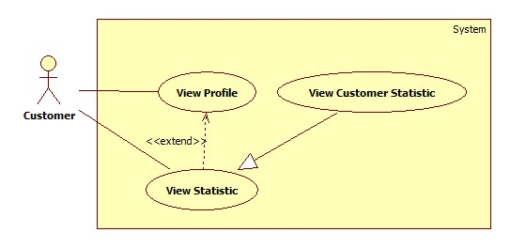

|  |  |  |  |  |
| --- | --- | --- | --- | --- |
| **USE CASE SPECIFICATION** | | | | |
| **Use-case No.** | UC… | **Use-case Version** | | 1.0 |
| **Use-case Name** | View Customer Statistic | | | |
| **Author** | TuanBT | | | |
| **Date** | 24/09/2014 | **Priority** | High | |
| **Actor:** Customer  **Summary:** …  **Goal:**  …  **Trigger:** …  **Pre-conditions:**   * User must login with Admin role * … page will be shown   **Post conditions:**   * Success: ... * Failure: ….   **Main Success Scenario:**   |  |  | | --- | --- | | Actor Action | System Response | | 1. | 2. |   **Alternative Scenario:**   |  |  | | --- | --- | | Actor Action | System Response | |  |  |   **Exceptions:**   |  |  | | --- | --- | | Actor Action | System Response | | [Exception 1]  1. | 2. |   **Relationships:** N/A  **Business Rules:** N/A | | | | |

##### <Guest> Register

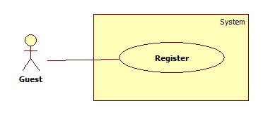

|  |  |  |  |  |
| --- | --- | --- | --- | --- |
| **USE CASE SPECIFICATION** | | | | |
| **Use-case No.** | UC001 | **Use-case Version** | | 1.0 |
| **Use-case Name** | Register | | | |
| **Author** | CongNT | | | |
| **Date** | 21/09/2014 | **Priority** | High | |
| **Actor:** Guest  **Summary:** This use case allows guest create an account in website system.  **Goal:**  It helps guest to create an account on website.  **Trigger:** Click on the “Đăng ký” button to register on home page  **Pre-conditions:**   * Page is loaded successfully * Register page will be shown   **Post conditions:**   * Success: Register successfully, guest will have an account in system and will be logged into system. * Failure: Show message error.   **Main Success Scenario:**   |  |  | | --- | --- | | Actor Action | System Response | | 1. Click on “Đăng ký” button home page 2. Input right information about username, email, password, full name, city, district, address, phone 3. Click on the “Đăng ký” button [Alternative 1] | 2. System redirect to register page for guest, contain a register form :   * Tên tài khoản [Username: textbox ] * Mật khẩu [Password : textbox] * Nhập lại mật khẩu [Repassword : textbox] * Địa chỉ email [Email: textbox]   In format: /^([a-zA-Z0-9_\.\-])+\@(([a-zA-Z0-9\-])+\.)+([a-zA-Z0-9]{2,4})+$/ .   * Họ và tên [Fullname : textbox] * Điện thoại[Phone : textbox] * Vai trò[Role : dropdownlist] * Đăng ký[button]  1. Validate valid username, password, email, phone 2. Redirect to register success page [Exception 1,2 3,4] |   **Alternative Scenario:**   |  |  | | --- | --- | | Actor Action | System Response | | 1. [Alternative 1] Click on the “MaidService” icon. | 1. Back to home page |   **Exceptions:**   |  |  | | --- | --- | | Actor Action | System Response | | 1. “Tên đăng nhập”,”Mật khẩu” ,”nhập lại mật khẩu” “Email” text-box is empty | 1. Display message: “Vui lòng nhập tên đăng nhập” or “Vui lòng nhập mật khẩu” or “Mật khẩu không trùng khớp” or “Vui lòng nhập số” or “Vui lòng nhập đúng định dạng abc@abc.abc” |   **Relationships:** N/A  **Business Rules:** N/A | | | | |

##### <Guest> Login

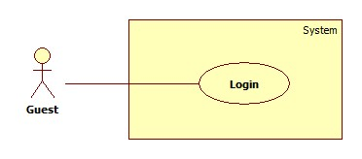

|  |  |  |  |  |
| --- | --- | --- | --- | --- |
| **USE CASE SPECIFICATION** | | | | |
| **Use-case No.** | UC002 | **Use-case Version** | | 1.0 |
| **Use-case Name** | Login | | | |
| **Author** | CongNT | | | |
| **Date** | 21/09/2014 | **Priority** | High | |
| **Actor:** Guest  **Summary:** This use case allow guest to login the website  **Goal:** Guest become a member of the website  **Trigger:** Click on the “Đăng nhập” button to login on home page  **Pre-conditions:**   * Page is loaded successfully * The login page will shown   **Post conditions:**   * Success: Login successfully, guest will have a role in system and can use more function of system. * Failure: Show message error   **Main Success Scenario:**   |  |  | | --- | --- | | Actor Action | System Response | | 1. Click on “Đăng nhập” button home page 2. Input right information about username, password 3. Click on the “Đăng nhập” button | 1. System redirect to login page for guest, contain a login form :  * Tên tài khoản [Username: textbox ] * Mật khẩu [Password : textbox] * Đăng nhập [button]  1. Redirect to login successful page |   **Alternative Scenario:**   |  |  | | --- | --- | | Actor Action | System Response | | 1. [Alternative 1] Click on the “Đóng” button. | 1. Back to home page |   **Exceptions:**   |  |  | | --- | --- | | Actor Action | System Response | | 1. “Tên đăng nhập”,”Mật khẩu” ,” is empty 2. “Tên đăng nhập”,”Mật khẩu” ,” is incorrect | 1. Display message “Vui lòng nhập tên đăng nhập” or “Vui lòng nhập mật khẩu” 2. Display message “Tên đăng nhập hoặc mật khẩu không đúng, vui lòng thử lại” |   **Relationships:** N/A  **Business Rules:** N/A | | | | |

##### <Guest > Search

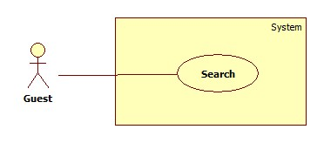

|  |  |  |  |  |
| --- | --- | --- | --- | --- |
| **USE CASE SPECIFICATION** | | | | |
| **Use-case No.** | UC003 | **Use-case Version** | | 1.0 |
| **Use-case Name** | Search | | | |
| **Author** | CongNT | | | |
| **Date** | 21/09/2014 | **Priority** | High | |
| **Actor:** Guest  **Summary:** This use case allow guest can search information by job  **Goal:** Guest can search information by search job  **Trigger:** Fill in “Tìm kiếm” textbox, then click on “Tìm kiếm” button  **Pre-conditions:**   * Page is loaded successfully * The search page will shown   **Post conditions:**   * Success: Search successfully, the system will shown search result * Failure:   **Main Success Scenario:**   |  |  | | --- | --- | | Actor Action | System Response | | 1. Fill in “Tìm kiếm” text box 2. Click on “Tìm kiếm” button | 1. System redirect to search page for guest and show search results |   **Alternative Scenario:**   |  |  | | --- | --- | | Actor Action | System Response | | 1. [Alternative 1] Click on the “MaidService” icon | 1. Back to home page |   **Exceptions:**   |  |  | | --- | --- | | Actor Action | System Response | |  |  |   **Relationships:** N/A  **Business Rules:** N/A | | | | |

##### < Guest >Advance Search

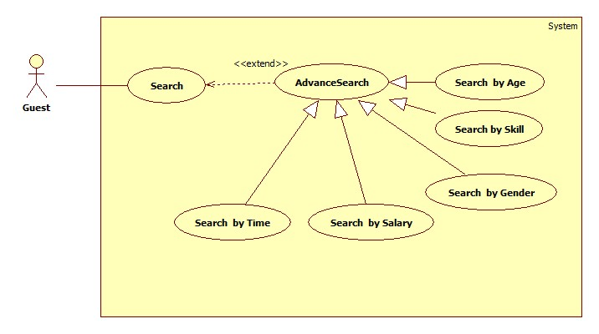

###### **<Guest> Search by job**

|  |  |  |  |  |
| --- | --- | --- | --- | --- |
| **USE CASE SPECIFICATION** | | | | |
| **Use-case No.** | UC005 | **Use-case Version** | | 1.0 |
| **Use-case Name** | Search by name | | | |
| **Author** | CongNT | | | |
| **Date** | 21/09/2014 | **Priority** | High | |
| **Actor:** Guest  **Summary:** This use case allow guest can search information by job  **Goal:** Guest can search information by search job  **Trigger:** Fill in “Tìm kiếm” textbox, then click on “Tìm kiếm” button  **Pre-conditions:**   * Page is loaded successfully * The search page will shown   **Post conditions:**   * Success: Search successfully, the system will shown search result * Failure:   **Main Success Scenario:**   |  |  | | --- | --- | | Actor Action | System Response | | 1. Fill in “Tìm kiếm” text box 2. Click on “Tìm kiếm” button 3. Click on “Nấu ăn” or “trông trẻ” link | 1. System redirect to search page for guest 2. Show the result suitable for each link |   **Alternative Scenario:**   |  |  | | --- | --- | | Actor Action | System Response | | 1. [Alternative 1] Click on the “Đóng” button. | 1. Back to home page |   **Exceptions:**   |  |  | | --- | --- | | Actor Action | System Response | |  |  |   **Relationships:** N/A  **Business Rules:** N/A | | | | |

###### **<Guest> Search by age**

|  |  |  |  |  |
| --- | --- | --- | --- | --- |
| **USE CASE SPECIFICATION** | | | | |
| **Use-case No.** | UC003a | **Use-case Version** | | 1.0 |
| **Use-case Name** | Search by age | | | |
| **Author** | CongNT | | | |
| **Date** | 21/09/2014 | **Priority** | High | |
| **Actor:** Guest  **Summary:** This use case allow guest can search information by age  **Goal:** Guest can search information by search age  **Trigger:** Fill in “Tìm kiếm” textbox, then click on “Tìm kiếm” button  **Pre-conditions:**   * Page is loaded successfully * The search page will shown   **Post conditions:**   * Success: Search successfully, the system will shown search result * Failure:   **Main Success Scenario:**   |  |  | | --- | --- | | Actor Action | System Response | | 1. Fill in “Tìm kiếm” text box 2. Click on “Tìm kiếm” button 3. Click on “25-30” or “30-35” or “35-40” link | 1. System redirect to search page for guest 2. Show the result suitable for each link |   **Alternative Scenario:**   |  |  | | --- | --- | | Actor Action | System Response | | 1. [Alternative 1] Click on the “Đóng” button. | 1. Back to home page |   **Exceptions:**   |  |  | | --- | --- | | Actor Action | System Response | |  |  |   **Relationships:** N/A  **Business Rules:** N/A | | | | |

###### **<Guest> Search by salary**

|  |  |  |  |  |
| --- | --- | --- | --- | --- |
| **USE CASE SPECIFICATION** | | | | |
| **Use-case No.** | UC006 | **Use-case Version** | | 1.0 |
| **Use-case Name** | Search by salary | | | |
| **Author** | CongNT | | | |
| **Date** | 21/09/2014 | **Priority** | High | |
| **Actor:** Guest  **Summary:** This use case allow guest can search information by salary  **Goal:** Guest can search information by search salary  **Trigger:** Fill in “Tìm kiếm” textbox, then click on “Tìm kiếm” button  **Pre-conditions:**   * Page is loaded successfully * The search page will shown   **Post conditions:**   * Success: Search successfully, the system will shown search result * Failure:   **Main Success Scenario:**   |  |  | | --- | --- | | Actor Action | System Response | | 1. Fill in “Tìm kiếm” text box 2. Click on “Tìm kiếm” button 3. Click on “Dưới 3 triệu” or “3-5 triệu” or “trên 5 triệu” link | 1. System redirect to search page for guest 2. Show the result suitable for each link |   **Alternative Scenario:**   |  |  | | --- | --- | | Actor Action | System Response | | 1. [Alternative 1] Click on the “Đóng” button. | 1. Back to home page |   **Exceptions:**   |  |  | | --- | --- | | Actor Action | System Response | |  |  |   **Relationships:** N/A  **Business Rules:** N/A | | | | |

###### **<Guest> Search by time**

|  |  |  |  |  |
| --- | --- | --- | --- | --- |
| **USE CASE SPECIFICATION** | | | | |
| **Use-case No.** | UC007 | **Use-case Version** | | 1.0 |
| **Use-case Name** | Search by time | | | |
| **Author** | CongNT | | | |
| **Date** | 21/09/2014 | **Priority** | High | |
| **Actor:** Guest  **Summary:** This use case allow guest can search information by time  **Goal:** Guest can search information by search time  **Trigger:** Fill in “Tìm kiếm” textbox, then click on “Tìm kiếm” button  **Pre-conditions:**   * Page is loaded successfully * The search page will shown   **Post conditions:**   * Success: Search successfully, the system will shown search result * Failure:   **Main Success Scenario:**   |  |  | | --- | --- | | Actor Action | System Response | | 1. Fill in “Tìm kiếm” text box 2. Click on “Tìm kiếm” button 3. Click on “Cách đây 1 ngày” or “Cách đây 3 ngày” or “Cách đây 5 ngày” or “Cách đây 7 ngày” or “Cách đây 14 ngày” or “Cách đây 30 ngày” link | 1. System redirect to search page for guest 2. Show the result suitable for each link |   **Alternative Scenario:**   |  |  | | --- | --- | | Actor Action | System Response | | 1. [Alternative 1] Click on the “Đóng” button. | 1. Back to home page |   **Exceptions:**   |  |  | | --- | --- | | Actor Action | System Response | |  |  |   **Relationships:** N/A  **Business Rules:** N/A | | | | |

###### **<Guest> Search by gender**

|  |  |  |  |  |
| --- | --- | --- | --- | --- |
| **USE CASE SPECIFICATION** | | | | |
| **Use-case No.** | UC008 | **Use-case Version** | | 1.0 |
| **Use-case Name** | Search by gender | | | |
| **Author** | CongNT | | | |
| **Date** | 21/09/2014 | **Priority** | High | |
| **Actor:** Guest  **Summary:** This use case allow guest can search information by gender  **Goal:** Guest can search information by search name  **Trigger:** Fill in “Tìm kiếm” textbox, then click on “Tìm kiếm” button  **Pre-conditions:**   * Page is loaded successfully * The search page will shown   **Post conditions:**   * Success: Search successfully, the system will shown search result * Failure:   **Main Success Scenario:**   |  |  | | --- | --- | | Actor Action | System Response | | 1. Fill in “Tìm kiếm” text box 2. Click on “Tìm kiếm” button 3. Click on “Nam” or “Nữ” link | 1. System redirect to search page for guest 2. Show the result suitable for each link |   **Alternative Scenario:**   |  |  | | --- | --- | | Actor Action | System Response | | 1. [Alternative 1] Click on the “Đóng” button. | 1. Back to home page |   **Exceptions:**   |  |  | | --- | --- | | Actor Action | System Response | |  |  |   **Relationships:** N/A  **Business Rules:** N/A | | | | |

##### <Staff> Manage JobRequest and Recruitment

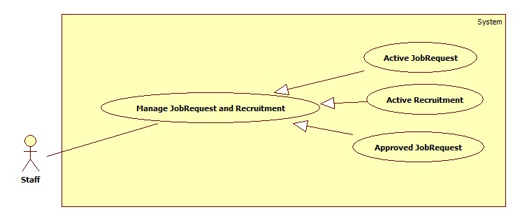

###### **<Staff> Active JobRequest**

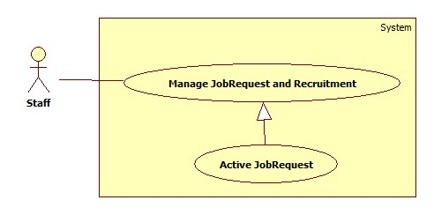

|  |  |  |  |  |
| --- | --- | --- | --- | --- |
| **USE CASE SPECIFICATION** | | | | |
| **Use-case No.** | UC038 | **Use-case Version** | | 1.0 |
| **Use-case Name** | Active JobRequest | | | |
| **Author** | CongNT | | | |
| **Date** | 21/09/2014 | **Priority** | High | |
| **Actor:** Staff  **Summary:** This use case allow staff to active job request to public it on website  **Goal:** Staff can allow job request to public on website  **Trigger:** User login as staff  **Pre-conditions:**   * Page is loaded successfully * User login as staff successful   **Post conditions:**   * Success: Login successfully, the job request will be allowed to public on website * Failure:   **Main Success Scenario:**   |  |  | | --- | --- | | Actor Action | System Response | | 1. Login as a staff 2. Choose a job request, click “Kích hoạt” button 3. Click “Chấp nhận” button. | 1. System redirect to list of job request 2. System show a “Xác nhận kích hoạt” pop up. 3. Change IsActive(false) to IsActive(true) and save change to database |   **Alternative Scenario:**   |  |  | | --- | --- | | Actor Action | System Response | | 1. Click on the “Đăng xuất” button. | 1. Clear session and back to home page |   **Exceptions:**   |  |  | | --- | --- | | Actor Action | System Response | | 1. System fail to load data | 1. Show message “Hệ thống đang bảo trì” |   **Relationships:** N/A  **Business Rules:** Staff | | | | |

###### **<Staff> Active Recruitment**

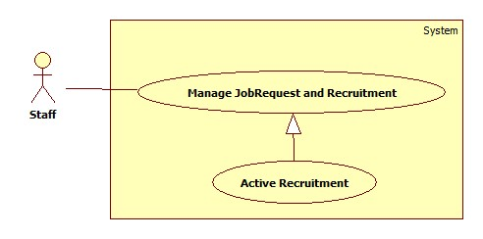

|  |  |  |  |  |
| --- | --- | --- | --- | --- |
| **USE CASE SPECIFICATION** | | | | |
| **Use-case No.** | UC039 | **Use-case Version** | | 1.0 |
| **Use-case Name** | Active Recruitment | | | |
| **Author** | CongNT | | | |
| **Date** | 21/09/2014 | **Priority** | High | |
| **Actor:** Staff  **Summary:** This use case allow staff to active job request to public it on website  **Goal:** Staff can allow job request to public on website  **Trigger:** User login as staff  **Pre-conditions:**   * Page is loaded successfully * User login as staff successful   **Post conditions:**   * Success: Login successfully, the job request will be allowed to public on website * Failure:   **Main Success Scenario:**   |  |  | | --- | --- | | Actor Action | System Response | | 1. Login as a staff 2. Click “Xác nhận hoàn tất công việc” link 3. Choose a recruitment, click “Hoàn tất” button 4. Click “Chấp nhận” button. | 1. System redirect to list of job request 2. System redirect to list of applied job requests 3. System show a “Xác nhận kích hoạt” pop up. 4. Change IsActive(false) to IsActive(true) and save change to database |   **Alternative Scenario:**   |  |  | | --- | --- | | Actor Action | System Response | | 1. Click on the “Đăng xuất” button. | 1. Clear session and back to home page |   **Exceptions:**   |  |  | | --- | --- | | Actor Action | System Response | | 1. System fail to load data | 1. Show message “Hệ thống đang bảo trì” |   **Relationships:** N/A  **Business Rules:** Staff | | | | |

###### **<Staff> Approve JobRequest**

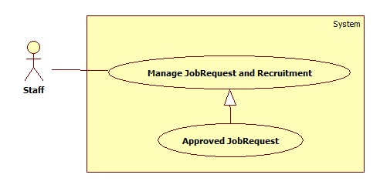

|  |  |  |  |  |
| --- | --- | --- | --- | --- |
| **USE CASE SPECIFICATION** | | | | |
| **Use-case No.** | UC040 | **Use-case Version** | | 1.0 |
| **Use-case Name** | Approve JobRequest | | | |
| **Author** | CongNT | | | |
| **Date** | 21/09/2014 | **Priority** | High | |
| **Actor:** Staff  **Summary:** This use case allow staff to active job request to public it on website  **Goal:** Staff can allow job request to public on website  **Trigger:** User login as staff  **Pre-conditions:**   * Page is loaded successfully * User login as staff successful   **Post conditions:**   * Success: Login successfully, the job request will be allowed to public on website * Failure:   **Main Success Scenario:**   |  |  | | --- | --- | | Actor Action | System Response | | 1. Login as a staff 2. Click “Kích hoạt yêu cầu tìm người” link 3. Choose a recruitment, click “Kích hoạt” button 4. Click “Chấp nhận” button. | 1. System redirect to list of job request 2. System redirect to list of recruitments 3. System show a “Xác nhận kích hoạt” pop up. 4. Change IsActive(false) to IsActive(true) and save change to database |   **Alternative Scenario:**   |  |  | | --- | --- | | Actor Action | System Response | | 1. Click on the “Đăng xuất” button. | 1. Clear session and back to home page |   **Exceptions:**   |  |  | | --- | --- | | Actor Action | System Response | | 1. System fail to load data | 1. Show message “Hệ thống đang bảo trì” |   **Relationships:** N/A  **Business Rules:** Staff | | | | |

##### <Staff> View Staff Statistic

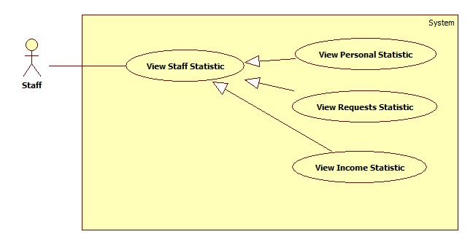

###### **<Staff> View Personal Statistic**

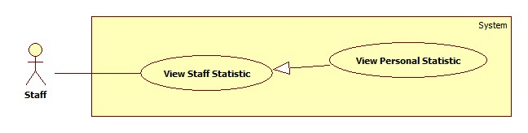

|  |  |  |  |  |
| --- | --- | --- | --- | --- |
| **USE CASE SPECIFICATION** | | | | |
| **Use-case No.** | UC034 | **Use-case Version** | | 1.0 |
| **Use-case Name** | View Personal Statistic | | | |
| **Author** | CongNT | | | |
| **Date** | 21/09/2014 | **Priority** | High | |
| **Actor:** Staff  **Summary:** This use case allow staff see personal statistic  **Goal:** Staff can see own statistic  **Trigger:** User login as staff  **Pre-conditions:**   * Page is loaded successfully * User login as staff successful   **Post conditions:**   * Success: Login successfully, the statistic will be shown * Failure:   **Main Success Scenario:**   |  |  | | --- | --- | | Actor Action | System Response | | 1. Login as a staff 2. Click name link 3. Click “Thống kê” link | 1. System redirect home page 2. System redirect personal profile page 3. System redirect personal statistic page and show personal statistic. |   **Alternative Scenario:**   |  |  | | --- | --- | | Actor Action | System Response | | 1. Click on the “Đăng xuất” button. | 1. Clear session and back to home page |   **Exceptions:**   |  |  | | --- | --- | | Actor Action | System Response | | 1. System fail to load data | 1. Show message “Hệ thống đang bảo trì” |   **Relationships:** N/A  **Business Rules:** Staff | | | | |

###### **<Staff> View Requests Statistic**

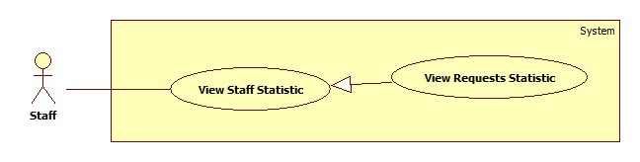

|  |  |  |  |  |
| --- | --- | --- | --- | --- |
| **USE CASE SPECIFICATION** | | | | |
| **Use-case No.** | UC042 | **Use-case Version** | | 1.0 |
| **Use-case Name** | View Requests Statistic | | | |
| **Author** | CongNT | | | |
| **Date** | 21/09/2014 | **Priority** | High | |
| **Actor:** Staff  **Summary:** This use case allow staff see requests statistic  **Goal:** Staff can see requests statistic  **Trigger:** User login as staff  **Pre-conditions:**   * Page is loaded successfully * User login as staff successful   **Post conditions:**   * Success: Login successfully, the statistic will be shown * Failure:   **Main Success Scenario:**   |  |  | | --- | --- | | Actor Action | System Response | | 1. Login as a staff 2. Click name link 3. Click “Thống kê” link 4. Click “Các yêu cầu” link | 1. System redirect home page 2. System redirect personal profile page 3. System redirect personal statistic page and show personal statistic. 4. System redirect personal statistic page and show personal statistic. |   **Alternative Scenario:**   |  |  | | --- | --- | | Actor Action | System Response | | 1. Click on the “Đăng xuất” button. | 1. Clear session and back to home page |   **Exceptions:**   |  |  | | --- | --- | | Actor Action | System Response | | 1. System fail to load data | 1. Show message “Hệ thống đang bảo trì” |   **Relationships:** N/A  **Business Rules:** Staff | | | | |

###### **<Staff> View Income Statistic**

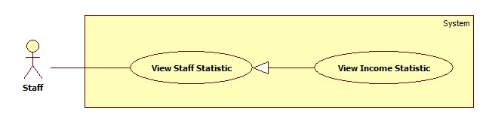

|  |  |  |  |  |
| --- | --- | --- | --- | --- |
| **USE CASE SPECIFICATION** | | | | |
| **Use-case No.** | UC043 | **Use-case Version** | | 1.0 |
| **Use-case Name** | View Income Statistic | | | |
| **Author** | CongNT | | | |
| **Date** | 21/09/2014 | **Priority** | High | |
| **Actor:** Staff  **Summary:** This use case allow staff see income statistic  **Goal:** Staff can see income statistic  **Trigger:** User login as staff  **Pre-conditions:**   * Page is loaded successfully * User login as staff successful   **Post conditions:**   * Success: Login successfully, the income statistic will be shown * Failure:   **Main Success Scenario:**   |  |  | | --- | --- | | Actor Action | System Response | | 1. Login as a staff 2. Click name link 3. Click “Thống kê” link 4. Click “Doanh thu” link | 1. System redirect home page 2. System redirect personal profile page 3. System redirect personal statistic page and show personal statistic. 4. System redirect income statistic page and show personal statistic. |   **Alternative Scenario:**   |  |  | | --- | --- | | Actor Action | System Response | | 1. Click on the “Đăng xuất” button. | 1. Clear session and back to home page |   **Exceptions:**   |  |  | | --- | --- | | Actor Action | System Response | | 1. System fail to load data | 1. Show message “Hệ thống đang bảo trì” |   **Relationships:** N/A  **Business Rules:** Staff | | | | |

##### <Staff> Manage Maid

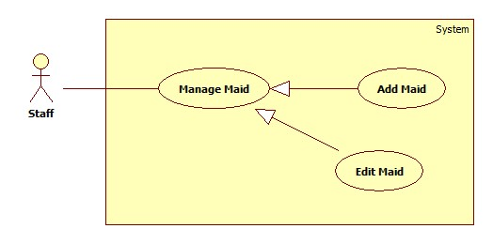

###### **<Staff> Add Maid**

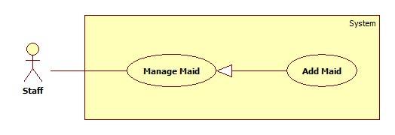

|  |  |  |  |  |
| --- | --- | --- | --- | --- |
| **USE CASE SPECIFICATION** | | | | |
| **Use-case No.** | UC035 | **Use-case Version** | | 1.0 |
| **Use-case Name** | Add maid | | | |
| **Author** | CongNT | | | |
| **Date** | 21/09/2014 | **Priority** | High | |
| **Actor:** Staff  **Summary:** This use case allow staff to add maids for management.  **Goal:** Staff can add maids  **Trigger:** User login as staff  **Pre-conditions:**   * Page is loaded successfully * User login as staff successful   **Post conditions:**   * Success: Login successfully, staff can add maids * Failure: Show messages   **Main Success Scenario:**   |  |  | | --- | --- | | Actor Action | System Response | | 1. Login as a staff 2. Click name link 3. Click “Thêm người tuyển việc” link | 1. System redirect home page 2. System redirect personal profile page 3. System redirect add maid page with following field:  * Họ và tên [MaidName: textbox] * Kinh nghiệm [Experience: dropdownlist] * Số điện thoại [Phone: textbox] * Ngày sinh [BirthDate: textbox] * Giới tính [Gender: dropdownlist] * Biết tiếng [LanguageEnglish: checkbox, LanguageChina: checkbox, LanguageJapanese: checkbox, LanguageKorean: checkbox] * Nguyên quán [Hometown: dropdownlist] * Đang sống tại [Address: dropdownlist] * Kết hôn [Married: dropdownlist] * Giới thiệu bản thân [Description: textbox] * “Hoàn tất người giúp việc” button. |   **Alternative Scenario:**   |  |  | | --- | --- | | Actor Action | System Response | | 1. Click on the “Đăng xuất” button. | 1. Clear session and back to home page |   **Exceptions:**   |  |  | | --- | --- | | Actor Action | System Response | | 1. “Họ và tên” is empty 2. “Số điện thoại” is empty or not a numberic value 3. “Ngày sinh” is empty | 1. Show message “Vui lòng nhập tên người giúp việc” 2. Show message “Vui lòng nhập số” 3. Show message “Vui lòng chọn ngày sinh” |   **Relationships:** N/A  **Business Rules:** Staff | | | | |

###### **<Staff> Edit Maid**

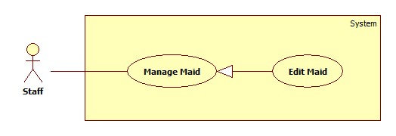

|  |  |  |  |  |
| --- | --- | --- | --- | --- |
| **USE CASE SPECIFICATION** | | | | |
| **Use-case No.** | UC042 | **Use-case Version** | | 1.0 |
| **Use-case Name** | Edit maid | | | |
| **Author** | CongNT | | | |
| **Date** | 21/09/2014 | **Priority** | High | |
| **Actor:** Staff  **Summary:** This use case allow staff edit own maids  **Goal:** Staff can edit own maids  **Trigger:** User login as staff  **Pre-conditions:**   * Page is loaded successfully * User login as staff successful   **Post conditions:**   * Success: Login successfully, staff can edit maids * Failure:   **Main Success Scenario:**   |  |  | | --- | --- | | Actor Action | System Response | | 1. Login as a staff 2. Click name link 3. Click maid name link 4. Click “Sửa thông tin người giúp việc” link | 1. System redirect home page 2. System redirect personal profile page 3. System redirect maid profile page 4. System redirect add maid page with following field:  * Họ và tên [MaidName: textbox] * Kinh nghiệm [Experience: dropdownlist] * Số điện thoại [Phone: textbox] * Ngày sinh [BirthDate: textbox] * Giới tính [Gender: dropdownlist] * Biết tiếng [LanguageEnglish: checkbox, LanguageChina: checkbox, LanguageJapanese: checkbox, LanguageKorean: checkbox] * Nguyên quán [Hometown: dropdownlist] * Đang sống tại [Address: dropdownlist] * Kết hôn [Married: dropdownlist] * Giới thiệu bản thân [Description: textbox] * “Hoàn tất người giúp việc” button. |   **Alternative Scenario:**   |  |  | | --- | --- | | Actor Action | System Response | | 1. Click on the “Đăng xuất” button. | 1. Clear session and back to home page |   **Exceptions:**   |  |  | | --- | --- | | Actor Action | System Response | | 1. “Họ và tên” is empty 2. “Số điện thoại” is empty or not a numberic value 3. “Ngày sinh” is empty | 1. Show message “Vui lòng nhập tên người giúp việc” 2. Show message “Vui lòng nhập số” 3. Show message “Vui lòng chọn ngày sinh” |   **Relationships:** N/A  **Business Rules:** Staff | | | | |

##### <Staff> Manage JobRequest

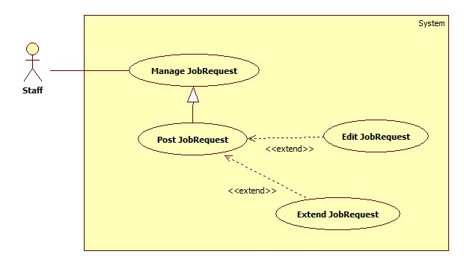

###### **<Staff> Post JobRequest**

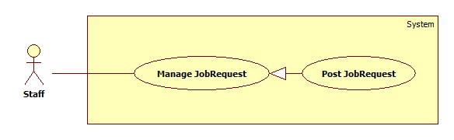

|  |  |  |  |  |
| --- | --- | --- | --- | --- |
| **USE CASE SPECIFICATION** | | | | |
| **Use-case No.** | UC037 | **Use-case Version** | | 1.0 |
| **Use-case Name** | Post jobrequest | | | |
| **Author** | CongNT | | | |
| **Date** | 21/09/2014 | **Priority** | High | |
| **Actor:** Staff  **Summary:** This use case allow staff to post jobrequest  **Goal:** Staff can post jobrequest  **Trigger:** User login as staff  **Pre-conditions:**   * Page is loaded successfully * User login as staff successful   **Post conditions:**   * Success: Login successfully, staff can post jobrequest * Failure: Show messages   **Main Success Scenario:**   |  |  | | --- | --- | | Actor Action | System Response | | 1. Login as a staff 2. Click “Đăng yêu cầu công việc” link | 1. System redirect home page 2. System redirect post jobrequest page with following field:  * Đăng cho [MaidName: textbox] * Tiêu đề [Title: dropdownlist] * Các kỹ năng [SkillRefId: textbox] * Thời hạn đăng [PostTime: textbox] * “Đăng yêu cầu” button |   **Alternative Scenario:**   |  |  | | --- | --- | | Actor Action | System Response | | 1. Click on the “Đăng xuất” button. | 1. Clear session and back to home page |   **Exceptions:**   |  |  | | --- | --- | | Actor Action | System Response | | 1. “Đăng cho” is empty 2. “Tiêu đề” is empty 3. “Các kỹ năng” is empty | 1. Show message “Vui lòng chọn người giúp việc” 2. Show message “Vui lòng nhập tiêu đề” 3. Show message “Vui lòng chọn kĩ năng” |   **Relationships:** N/A  **Business Rules:** Staff | | | | |

###### **<Staff> Edit JobRequest**

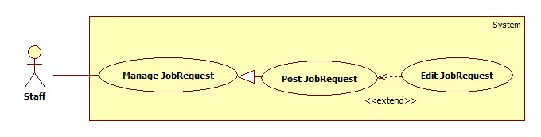

|  |  |  |  |  |
| --- | --- | --- | --- | --- |
| **USE CASE SPECIFICATION** | | | | |
| **Use-case No.** | UC042 | **Use-case Version** | | 1.0 |
| **Use-case Name** | Edit jobrequest | | | |
| **Author** | CongNT | | | |
| **Date** | 21/09/2014 | **Priority** | High | |
| **Actor:** Staff  **Summary:** This use case allow staff edit jobrequest  **Goal:** Staff can edit jobrequest  **Trigger:** User login as staff  **Pre-conditions:**   * Page is loaded successfully * User login as staff successful   **Post conditions:**   * Success: Login successfully, staff can edit maids * Failure:   **Main Success Scenario:**   |  |  | | --- | --- | | Actor Action | System Response | | 1. Login as a staff 2. Click name link 3. Click maid name link 4. Click title link at “Chờ nhận” tab or “Tạm ẩn” tab 5. Click “Sửa thông tin yêu cầu công việc” link | 1. System redirect home page 2. System redirect personal profile page 3. System redirect maid profile page 4. System redirect jobrequest info page 5. System redirect edit jobrequest page with following field:  * Đăng cho [MaidName: textbox] * Tiêu đề [Title: dropdownlist] * Các kỹ năng [SkillRefId: textbox] * Thời hạn đăng [PostTime: textbox] * “Sửa thông tin” button |   **Alternative Scenario:**   |  |  | | --- | --- | | Actor Action | System Response | | 1. Click on the “Đăng xuất” button. | 1. Clear session and back to home page |   **Exceptions:**   |  |  | | --- | --- | | Actor Action | System Response | | 1. “Họ và tên” is empty 2. “Số điện thoại” is empty or not a numberic value 3. “Ngày sinh” is empty | 1. Show message “Vui lòng nhập tên người giúp việc” 2. Show message “Vui lòng nhập số” 3. Show message “Vui lòng chọn ngày sinh” |   **Relationships:** N/A  **Business Rules:** Staff | | | | |

### Software System Attributes

#### Reliability

* There is no requirement for system maintenance task from the user.
* Mean Time Between Failures (MTBF): more than 6 months.
* Accuracy: 100%.
* Maximum Bugs and Defect Rate: 0.3 bugs per thousand lines of code (0.3bugs/KLOC).
* Critical bugs:
* Loss of data: not any

#### Availability

* The server shall be working 24 hours per day and 7 days per week.

#### Security

* *All sensitive* information (password, etc.) must be hashed when storing in database and during transmission over networks using MD5 hash.
* Validate input data in SQL query before execute to avoid SQL Injection, XSS
* The role of user and member is clearly.

#### Maintainability

* All code shall fully document. All program files shall include comments concerning authorship and date of last change.
* The code shall be modular to permit future modifications.

#### Portability

* The software will design as cross-platform software.

#### Performance

* Large tables and indexes must be partitioned data into smaller, more manageable sections by using partition in SQL Server 2008 R2

## Entity Relationship Diagram or Data Structures

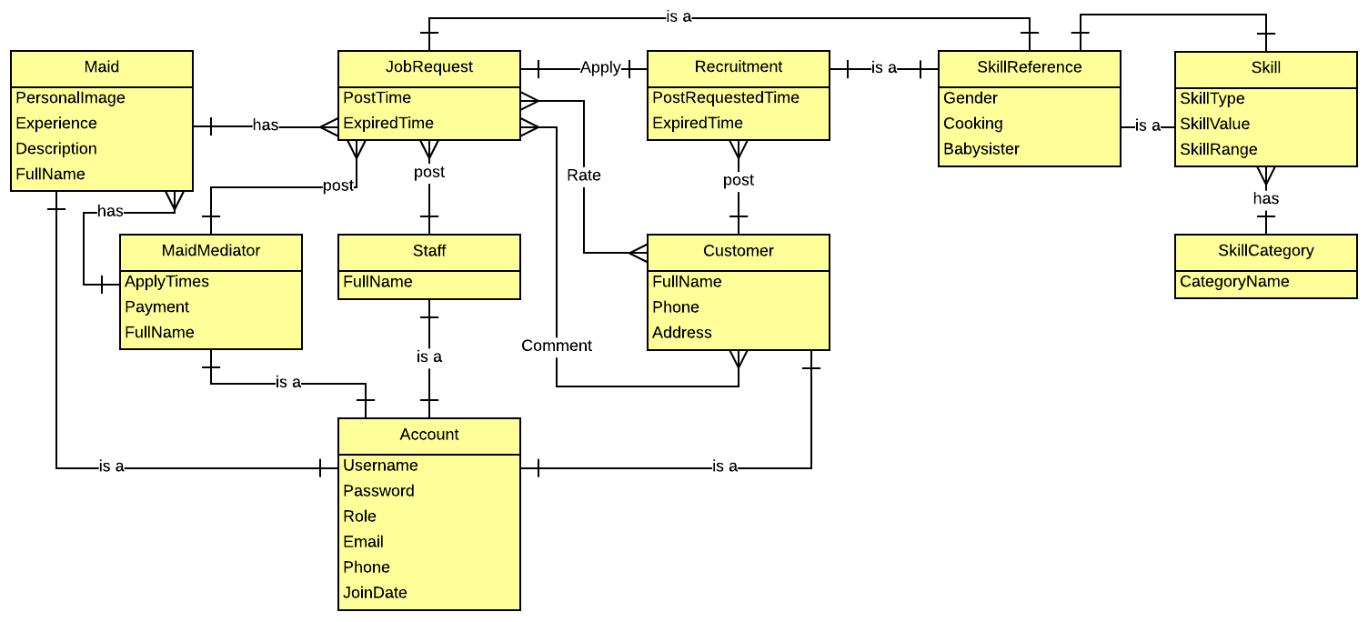

## Other material (if any)

N/A